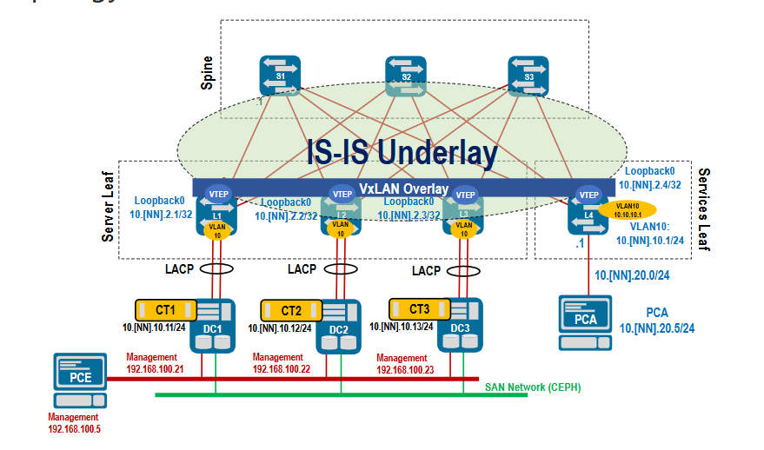
Spine
router isis DC
net 49.0000.0000.0001.0003.00
is-type level-2
log-adjacency-changes
!
address-family ipv4 unicast
metric 10000
!
!
interface Loopback0
ip address 10.46.1.3/32
isis enable DC
isis passive
!
interface ethernet 1-4
ip address unnumbered Lo0
mtu 1600
isis enable DC
isis network point-to-point
!
Leaf

router isis DC
net 49.0000.0000.0002.0001.00
is-type level-2
log-adjacency-changes
!
address-family ipv4 unicast
metric 10000
!
!
interface Loopback0
ip address 10.46.2.1/32
isis enable DC
isis passive
!
interface ethernet1-3
ip address unnumbered Lo0
mtu 1600
isis enable DC
isis network point-to-point
!
!

configure vxlan
L1, L4, L3, L2

interface vxlan1
vxlan source-interface loopback0
vxlan vlan 10 vni 1010
vxlan flood vtep 10.46.2.1 10.46.2.2 10.46.2.3 10.46.2.4

